MEDIA CONTACT:
John Yearwood,
Oualie Realty Limited,
P: 869-662-9740 / E: oualie1@gmail.com for immediate release

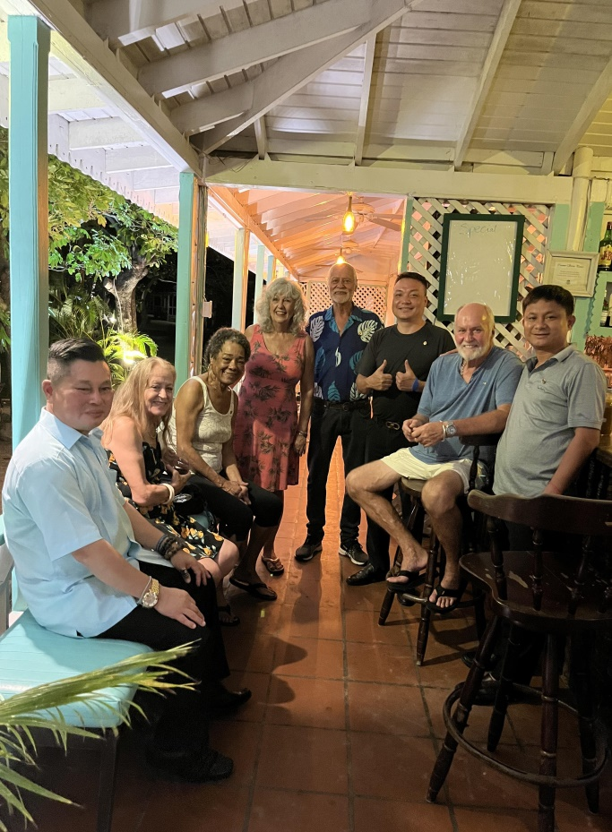
OUALIE REALTY HOST VIETNAM INVESTMENT DELEGATION

Oualie Realty Limited and the Yearwood family were delighted to host an investment delegation from Vietnam from 9-14th October 2023. The delegation was led by General Doan Thanh Hai, assisted by Lai Anh Tuan and Nguyen Anh Ngoc of the Nan Group. The delegation was accommodated at the Oualie Beach Resort on Nevis owned by the Yearwood family. The delegation visited various areas of Nevis and St Kitts to view potential areas of future investment co-operation. According to Mr. Nguyen Anh Ngoc “There is a demand in Vietnam and surrounding Asian countries from persons wishing to obtain the excellent second passport from St Kitts and Nevis that allows visa free travel to many countries.”

The investment group were particularly interested in the previously approved CBI real estate projects of Jones Estate Villas, the Kingfisher Club at Oualie and the Sea Haven Resort and Marina Project at Lovers Beach. Other potential commercial projects were
discussed including viewing various large tracts of land for potential villa developments; planting valuable Sandalwood forests; fish farming using cages in the sea; and transforming the invasive Sargasso seaweed into saleable products. John Yearwood commented “We should not allow the economies of Nevis and St Kitts to stagnate. It is time that our local businesses look at Asia for a new source of ideas and investment in our Federation.”

On their return to Vietnam the Investment Group will also explore the possibility of a direct flight from Ho Chi Minh City to the USA via St Kitts, as a transit stop on the journey. This would open up our shores to Asian tourists and investors.

